1. Fetch Data Daily
- Use your existing getAllNpsJobs function to fetch the data from the USAJOBS API at 9:00 AM ET.
- Scheduler: Your scheduler.js handles this, so you're set for automating the process.

2. Parse and Save to the Database
- Parse the API response to extract the data you want (e.g., job title, location, etc.).
- Before saving the new data:
  - Clear Old Data: Use a query like TRUNCATE TABLE jobs or DELETE FROM jobs to remove all records from the table.
  - Insert New Data: Insert the parsed jobs into the database.

3. Display Data on a Map
- Frontend:
  - Use a library like Leaflet.js (simple and free) or Google Maps API (more advanced, requires a key).
  - Fetch the job data from your server’s API (e.g., /jobs endpoint).
  - Plot the jobs on the map with markers.
- Backend:
  - Add an API route (e.g., /jobs) to serve the job data stored in the database.

4. Technology Stack
- Backend: Node.js with Express.js.
- Database: MySQL (or PostgreSQL, if you decide to switch).
- Frontend: HTML, CSS, JavaScript, and a map library like Leaflet.js or Google Maps API.

Example Workflow
- Daily Data Update:
  - Scheduler triggers the API call.
  - Data is fetched, parsed, and stored in the database.
- User Requests the Map:
  - User visits the site, and the frontend sends a request to /jobs.
  - The backend retrieves job data from the database and returns it as JSON.
  - Frontend plots the job data on the map.

Next Steps
- Database Design:
  - Plan your database schema for storing jobs (e.g., job ID, title, organization, location, etc.).
- Backend Development:
  - Set up routes to clear old data, save new data, and serve job data to the frontend.
- Frontend Development:
  - Create a map page and implement JavaScript to fetch data and display markers.
- Testing:
  - Test fetching, parsing, saving, and displaying data locally.

1/24/2025
Get and clean all jobs is successfully requesting the API data and then “cleaning” it by stripping out just the data we want to use on our map/website.

Can now do one of two things. Write a separate function to then process that data and save it in the DB. Or, alternatively, build another code block in the cleaning function and save the data to the DB immediately after cleaning it.

1/26/2025
Okay. You are working in parkJobs directory.
The API is sorted. Our function is one-stop. It gets the data, cleans it, saves it to the DB. Yes, we got the DB part working today. I think it is easier to do this with just calling and storing API data instead of building a CRUD app where users can manipulate data etc. Or at least, it’s easier to design the DB/tables when it a simple app and when we’re not developing a DB with end users in mind and needing to change and adapt our tables after we get back user input on what they want.
That’s a more advanced project and I’m OK with that.
What we’re building:
- Get the data.
- Clean the data.
- Store the data.
- Present the data to the user.
That’s it.
So our function calls the API, retrieves the data, cleans it, saves it to the DB.
I followed the leaflet basic example, changed the coordinates to center on Washington DC. And then played around with the pin and pop up code on their website.
In the project there is now a map.js file. That is where the majority of the leaflet (the map) code will live.
We need to figure out how to get data from the database, iterate through it, and then put jobs in pins.
A couple considerations:
- Some jobs might have the same location.
- There will be jobs with multiple locations.
- There will be jobs with no location or “location negotiable after selection”.
- There may be remote jobs.
I think what I want to do is this:
- Jobs that have just one location will be mapped.
- Jobs that have multiple locations, are location negotiable after selection, or are remote, will get pulled/flagged from the data and then we’ll present those in a table/list beneath the map.
When a user clicks a pin, all the jobs at that location will display in a pop up box with basic information and the apply URL/link to USA jobs.
Backed up to a local git and pushed to remote on github.

How the data is sent from our database to our API endpoint (/park/jobs):
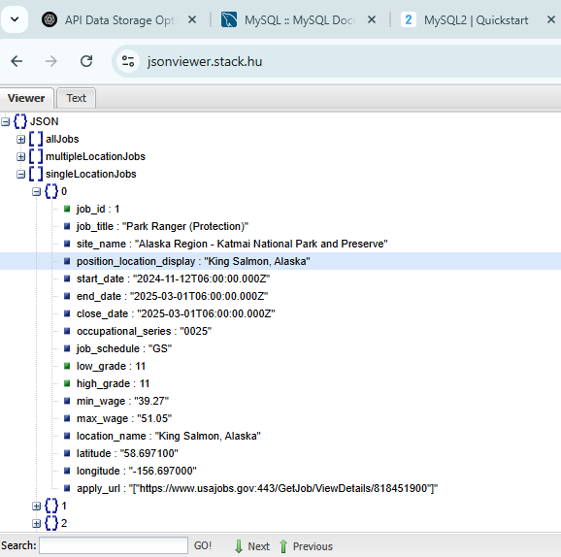
We have a JSON object, then three lists, then jobs are stored numerically 0, 1, 2, 3… as objects with K:V pairs of the data we wanted and retrieved from the USA Jobs API.

So far, we have successfully made it so that our code iterates through the singleLocationJobs object and then plots those jobs on the map and displays the job title, site name, location, and URL.
Working on making the URL clickable.
Note that the apply_url when sent along our endpoint is lower case AND it is storing the link with quotes and square brackets. I’m not positive but I think it’s storing the link as an array? I think it does this because when a job does have multiple locations, there are multiple links, maybe? Probably not. IDK. But we’ll have to work with it as is.

In the future, we can view the raw data ourselves by visiting our endpoint /park/jobs and using “pretty-print” to view the structure of our data:

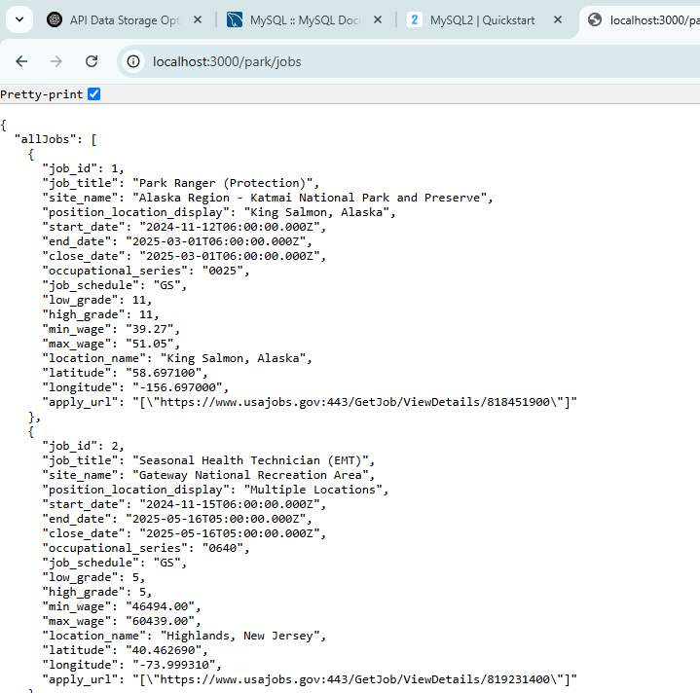

What we’ve achieved so far:
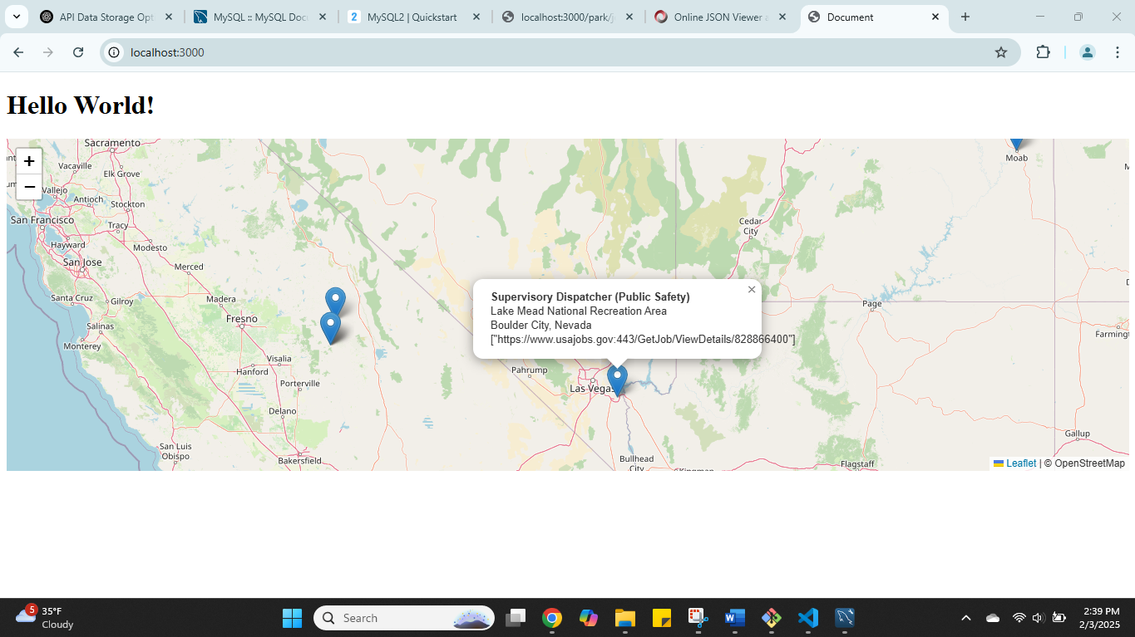

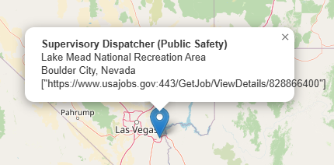

Used a string method and regex expression to strip off the square brackets and quotation marks from the apply URL and got the link in the popup to work.

And made it such that a table of other multiple location jobs appears below the map.

Need to add extra content/context to the different elements (the map, the table) so users know what the deal is. I also want to make the table scrollable and only show about 10 rows (or less) at a time).
Table is now scrollable. CSS stylesheet in CSS folder is what enables the scrolling.
Front end design is still required.
The bare bones of the site is there, but need definite refining on the front end and back end. But I think we’re almost to an MVP, as it were.
To finalize the “MVP” status, I would want the code to have a few things:
- More modularization, more organized code
  - Re-organization of the .js files and placing them in the JS folder.
  - Weed out all the test/placeholder functions etc and only retain what we need.
- Make sure that the “cron” job actually runs, and simulate a test of this by activating the server and keeping the code up and running at the appropriate time to make sure the cron job code runs and executes correctly.
  - We have the cron job code, but need to make sure we can run it/that it runs on time, that it dumps and saves the new data correctly, and that we’re able to retrieve the new data.
- Make it look not like dog shit.
- I’m sure there’s more but that’s about it for now.

In the JS folder there is now the JS file called dumpGetCleanSave.js with a function called “dumpGetCleanSaveAllNpsJobs” that should check if there is data in the jobs table first, and if so, dump it, then it should submit an API call to USA Jobs for new data, clean it, and save it to our database.
The dumpGetCleanSaveAllNpsJobs function was imported into the scheduler.js file which is at the topmost/root file of the app.
Later this week we’ll work on testing the scheduling, dropping, and saving.

2/8/2025
Teste the cron-node schedule.js file and it worked! Successfully scheduled the deletion of old data, as well as the calling, parsing, and saving of new data.
Sweet—the main function of the website is complete. I think we’re basically done. The only thing left would be handling edge cases and doing some data validation, but all-in-all I think we’re ready to move on to not making the website look like dog shit.
I have a HTML/CSS bootcamp Udemy course that I’ll take to “refresh” my knowledge, AKA re-learn it. And hopefully it provides enough that I can make something that isn’t doody.

Going to be done for now though and backup the code on github.

